**Cover Page**

*CE318 – High-Level Games Development*

**Tower Above**

**Overview**

The overall genre of this game is Tower Defense. What is Tower Defense? It’s is a genre of the game that requires you to place defensive structures that will allow you to defend an objective from wave of enemies or waves if we are talking about several stages. Defensive structures must be placed strategically, keeping in mind that they need to be purchased using money that is limited

**Gameplay**

Player must put down defensive structures onto the tower placeable areas, which are plain ground, without any obstacles or environmental objects. These defensive structures cost money, that is steadily increasing as time goes, which means players must put them carefully at the strategical spot / tile. Player starts with a bit of money so a few towers could be placed at the start of the game. The enemies are trying to get through the endpoint where they attack the base that these defensive structures are defending. If several enemies get through, game is lost. Player also sees the whole map zoomed out. Player can see the score of how many enemies were killed. Also killing an enemy grants player an extra bit of money. Enemies follow the path to get to the end, so player needs to keep track of money and hearts not to lose the game.

**Interface**

Splash Screen:

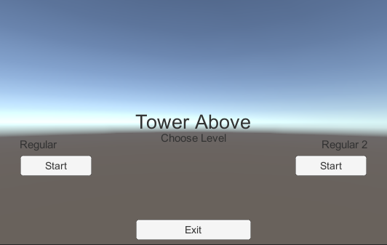

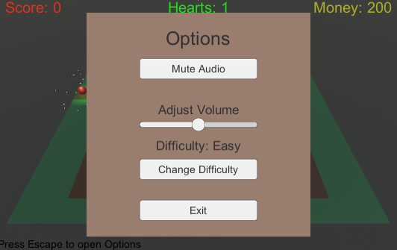

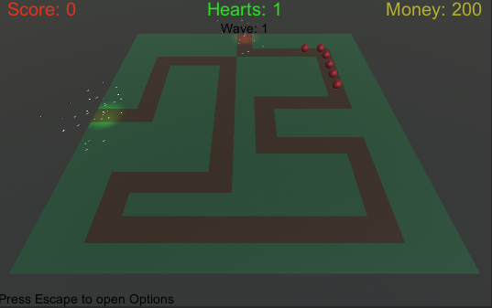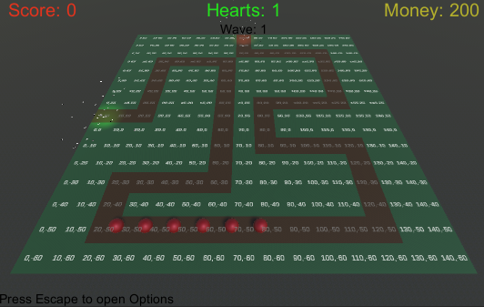

Score is displayed at the top left corner of the screen that shows how many enemies got killed (All the white text apart from coordinates was drawn with Paint)

Money is displayed at the top right corner of the screen

The Defeat is shown in the center of the screen after losing

Coordinates and rectangles at the edges of the screen only appear in Debug Mode, that is toggled by pressing Space key.

Towers can be places on Coordinates that are white, by left clicking with a mouse.

The game is paused by pressing P Key and Paused is shown in the middle of the screen.

Pressing Esc key brings the menu to choose different playable mode. (Options)

Pressing O key Mutes the game

Hearts are shown in the top-middle of the screen.

Menu has 4 options: Mute Audio, Adjust Volume using a slider, Change difficulty, and Exit (To splash screen)

**Objectives**

The main objective of this game is to survive the invasion of these enemies that try to get to the base that will lead to losing if several get through. Another objective is to track the amount of money to keep on putting down defensive structures. This genre of games is very simple so there aren’t many objectives.

**Look & Feel**

The game has 2 playable levels. These levels are played on endless mode, which is just divided into waves. The number of enemies increases on every stage. The background theme that is playing is taken from my favourite 2D Tower Defense game called The Battle Cats. Link: <https://youtu.be/ef_9osknmyw>

The game is inspired by Bloons TD 5, that I used to play a lot several years ago.

The reason why I chose this genre is because I’m planning on releasing a game on mobile in this genre. And overall, I spent probably too much time on these kinds of games, mostly Bloons TD 5 and The battle cats, I could say I spent 100+ hours playing them. Another honourable mention would be Age of war and Age of war 2.

The way current game looks like is straight up one of the Bloons TD 5 maps, 3D version of course.

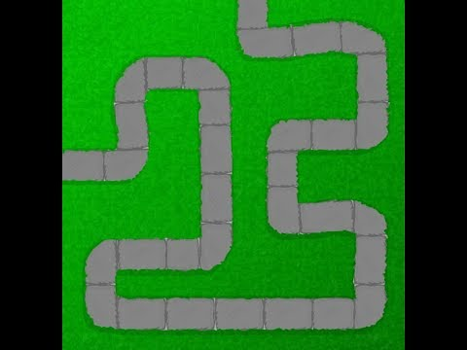

**Story**

The main character of this game is a king that resides inside the tower / base that enemies try to get into. This king is a player who plays this game, thus this character is not seen within the game, but is constantly controlling the realm and building new defensive structures, anything that will save him from unknown enemies that try to take him down. The reason king is prepared is because clairvoyant of the realm (developer) told so. “Look to their coming on the first light of the fifth day, at dawn look to the east. “

So, the whole plot is pretty much same as most of the Tower Defense games, defend the *Tower* from invaders.

**Referencing Assets**

Packs folder contains TextMesh Pro that was used to display Coordinates onto tiles for debug purposes.

Audio Folder contains The Battle Cats theme song: <https://youtu.be/ef_9osknmyw>

And explosion_player taken from lab 2

SurfaceTextures > Grass Hill Albedo was taken from ‘Standard Assets’

Standard assets, by Unity Technologies (<https://assetstore.unity.com/packages/essentials/asset-packs/standard-assets-for-unity-2018-4-32351>)

Screen fading was taken from lab 3 and removed unnecessary lines of code.

Fading (black picture) was also taken from lab 3

The version of Unity used: **2020.3.22f1**

I have decided to remove the feature where camera was zoomed in and player could move the screen by dragging the cursor close to the edges, because in feedback I was asked to change position of the camera to enable the player to have full visibility of the game.

I did not use NavMesh Pathfinding because that would overcomplicate the game logic and I couldn’t find it of use. The way I’m implementing enemy movement is much simpler and cleaner than using Navmesh, there are clear advantages of doing so, because custom scripts are always better than built-in unity features.

I’m using terrain as a background.

**How the game is played**

The game starts with a splash screen, saying the name of the game and my name. That leads to the main menu which shows the name of the game in the middle, 2 different levels that can be played, Regular and Regular 2 and Exit that exits out from the application. Pressing any of the Regular and Regular 2 leads to different looking scene. Once it is pressed, the game starts, and wave spawns. Every waves the amount of enemies increases. Player can put down towers using mouse left click that will shoot enemies. At the start player has only enough money to put down 4 towers, strategically. Money increases every time an enemy dies. Hearts decrease every time enemy reaches an end point which highlighted by the red light. Pressing P pauses the game, pressing O mutes the game, pressing Escape shows the options menu. Pressing Exit in options menu goes back to the splash screen.